CPEG 207 Digital Systems HOMEWORK 5
Name: _______________________________________________
Show your work detail and clearly identify your answer.
- A) For the full-adder, determine the outputs for the following inputs
A = 1, B = 1, C_{in} = 1
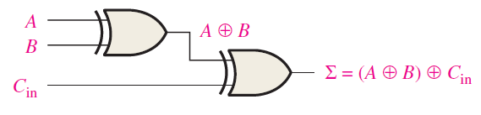 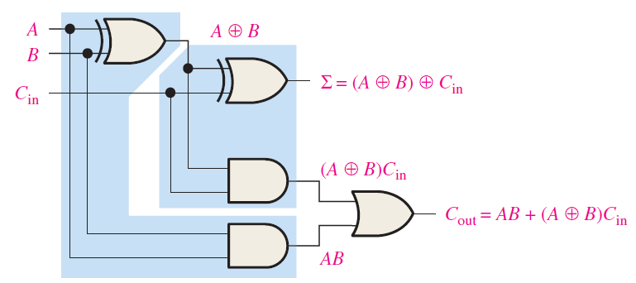
XOR (upper) output = , Sum output = , AND (upper) output = ,
AND (lower) output = , Carry output =
B) What are the half-adder inputs that will produce the following outputs:
Σ = 1, C_{out} = 0
A = , B = , C_{in} = or A = , B = , C_{in} = 0 or A = , B = , C _{in} =
C) Determine the outputs of a full-adder for the following inputs:
A = 0, B = 1, C_{in} = 1
- A) For the parallel adder, determine the complete sum by analysis of the logical
operation of the circuit. Verify your result by longhand addition of the two input numbers.
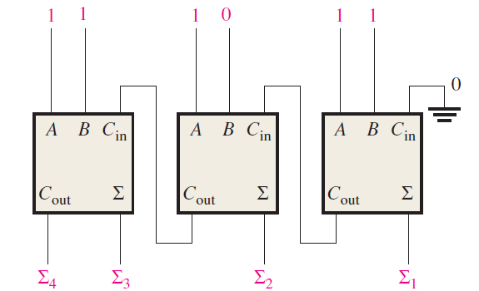
B) Repeat for the following circuit and input conditions.
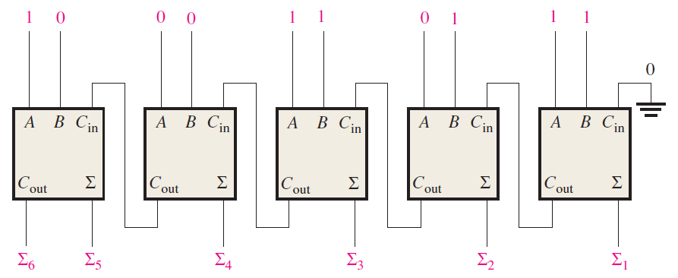
3. A) The input waveforms are applied to a 2-bit adder. Determine the waveforms for the
sums Σ₁ , Σ₂ and the output carry C_{out} in relation to the inputs by constructing a timing
diagram.
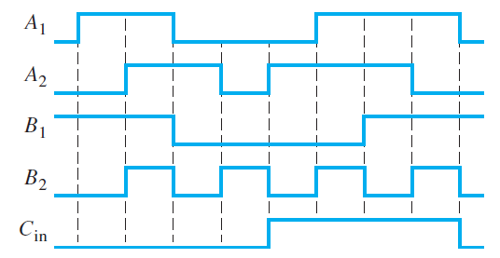

4. A) The waveforms are applied to the comparator as shown. Determine the output
(A = B) waveform.
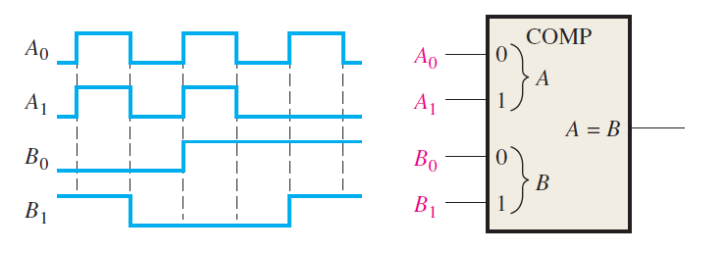
B) For the 4-bit comparator, plot each output waveform for the inputs shown. The
outputs are active-HIGH.
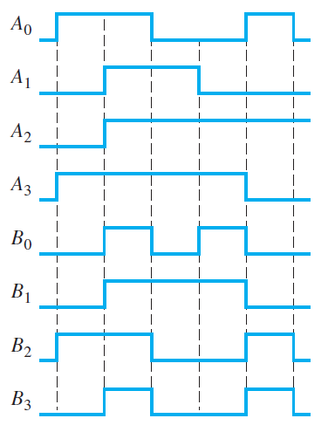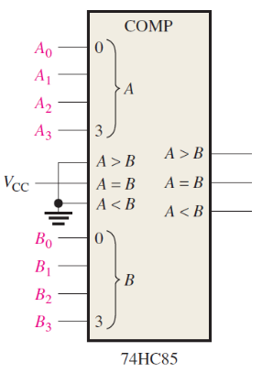

5. For each set of binary numbers, determine the output states for the comparator
(a) A3A2A1A0 = 1100 (b) A3A2A1A0 = 1000 (c) A3A2A1A0 = 0100
B3B2B1B0 = 1001 B3B2B1B0 = 1011 B3B2B1B0 = 0100

